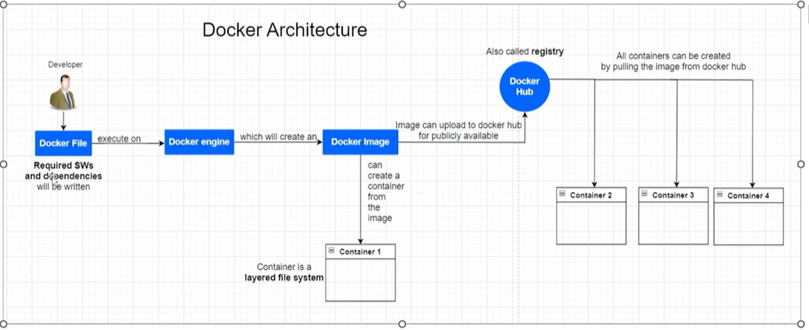

**1. Docker Engine:**  
Docker Engine is the core software that enables containers to run. It's a lightweight runtime and tooling that runs on the host operating system. The Engine is responsible for building, running, and managing containers, using the Linux kernel's features like cgroups and namespaces for isolation.

**2. Docker Client:**  
The Docker Client is the primary user interface for Docker. When you type commands in the terminal using docker, the client sends these commands to the Docker daemon (dockerd). It acts as a bridge between the user and the Docker Engine, making it simple to manage containers and images.

**3. Docker Host:**  
The Docker Host is the physical or virtual machine where the Docker Engine is installed. It provides the environment to run and manage containers. It includes the operating system, Docker Engine, and all the containers and images required for application deployment.